T H E B I R D P A C K E T :
A reference guide for basic bird care

Yearly Check Ups for Birds

Birds benefit greatly from regular veterinary check ups. Since birds commonly mask signs of illness for as long as possible, a regular yearly veterinary physical examination is important to help detect problems early and to establish a normal “baseline” for your bird. Additional testing is recommended based on your bird’s age and past medical history, and any abnormalities that might be found during the physical examination. These can include a complete blood count, a biochemistry panel, fecal analysis, radiographs or more.
Stress and the Veterinary Visit
Tips on how to make the Veterinary exam a more pleasant and less stressful experience for you and your bird

In years past it was not uncommon for veterinarians unfamiliar with birds to attempt to handle them using techniques that caused fear and anxiety for the birds. These included the use of gloves, and simply grabbing birds quickly and forcefully to reduce the risk of being bitten. This generally resulted in a stressful fear response that was almost guaranteed to reoccur each time the bird visited the veterinary hospital.

We now know that it is possible to handle nearly all pet birds in such a way to reduce stress and result in an experience that ranges from pleasant to only mildly annoying.
This does not happen without work on the part of the owner and the veterinary staff. Training the bird to accept handling must be practiced regularly for the entire lifetime of the pet.

Using positive reinforcement and practice you should be able to train your bird to:
- Willingly enter the carrier to come to the veterinarian
- Willingly step onto the scale to be weighed
- Willingly leave owners to step onto the examination table
- Accept towel restraint without fear

Entering the carrier
See our video on training your bird to enter the carrier at www.exoticvetclinic.com under the “education” and “video” links.

The transport carrier or box should not be used only when the bird has to go to the veterinarian, or it will become associated with veterinary visits. Young birds should regularly be placed into the carrier and rewarded, and occasionally be taken for short trip with treats as a reward for good behavior

Older birds that are fearful of or resist going into the carrier can be conditioned to go into the carrier for a reward. Some tips include:
- Reward the bird for standing on top of or near the carrier at first.
- Train the bird to respond to a target that is placed closer and closer to the carrier, and eventually in the carrier. (See “Target Training”)

Standing on the scale
See our video on weighing your pet at home at www.exoticvetclinic.com under the “education” and “video” links.

Accept Towel Restraint
There is probably not much that can be done to train a bird to actually enjoy towel restraint and examination, but most birds can learn that restraint is only mildly annoying and at least tolerate it. Success depends on constant positive reinforcement at home before and in between veterinary visits.

This is easiest to accomplish in young birds. We recommend “Towel Peek-a-boo.” Gently cover the bird with a towel, remove it and praise and reward the bird. Repeat regularly for the life of the bird.

Older birds already fearful of towels take much more effort. Begin by target training, and move the target closer and closer to a towel spread flat out on a table surface (see “Target Training.”) Practice until the bird will step onto the towel to reach the target. Wiggle one corner of the towel and reward the bird for sitting calmly. Gradually move more and more towel towards the bird until you can cover the bird completely. More fearful birds may require months of training to accomplish this.

Additional Tips: Bring a familiar towel and favorite treats to the veterinary exam for the staff to use.

IS MY BIRD SICK?

All exotic pets are susceptible to a variety of diseases, including infectious (bacterial, viral and fungal), organ disease, and even cancer. Unlike traditional pet species like dogs and cats, birds try very hard to hide any sign of illness. In the wild, obviously ill or injured birds attract the attention of predators; for this reason birds maintain an “I’m okay” attitude until they no longer can do so. Many birds that present to the veterinarian for a sudden illness have actually been sick for much longer. As a result, many bird owners need to be aware of small, subtle changes that may signal illness.

Start by carefully observing your healthy bird’s normal behavior and habits. Once you know normal, it will be easier to spot abnormal. Here are some things on the “check list”:

Behavior: This is often the first hint something is not right. A normal bird is active, vocal and interested in the surroundings. A sick bird may be fluffed up, sitting in one spot, appearing sleepy, or even sitting on the cage bottom. Some sick bird may appear normal when you are present, but not when left alone. Try to observe your bird without being seen. Other unusual behaviors may include decreased activity and vocalization, or even increased attention seeking. Be aware of any change in behavior that might suggest something is wrong.

Droppings: Normal bird droppings have three components. The dark, solid portion is feces. The white part is urates, or solid urine. The clear liquid portion is liquid urine. The color of the solid portion may change, depending on what the bird has eaten (red pellets may produce an orange color, and green pellets more green). The volume and firmness should remain consistent. Small dark fecal portions indicate the bird is not eating well. Liquid or runny fecal portions could be true diarrhea. The solid urine is usually white; changes in color could indicate illness. The amount of liquid urine increases when birds drink more or eat more soft foods, but excessive urine can be another sign of disease. One or two abnormal droppings are usually nothing to worry about, but consistently abnormal droppings over an entire day or two is a cause for concern. Blood in the droppings is always abnormal.

Appetite: Many birds continue to eat up until very ill. Some birds go through the motions of eating, but drop food instead of eating it (this is why monitoring feces is more important than monitoring time spend eating). Any changes in appetite may be a cause for concern.

Body condition: If you are worried about weight loss, carefully restraint your bird and run your finger down the center of the breast. You should be able to feel the keel bone running in the middle of the breastbone. A healthy bird should have muscle on either side of the bone. A bird that has lost weight will have a very “pointy” protruding keel bone. Be familiar with how this feels in your healthy bird so you will be able to detect a change (*refer to diagram later in this packet). An even better tool that does not require restraint is monitoring body weight with a gram scale. Weigh birds 3-4 times weekly and record the weight. Weight can change from day to day, but trends upwards and downwards can be a cause for concern. See our website for a video on how to weigh your exotic pet (www.exoticvetclinic.com) under the “education” and “video” links.

If you suspect that something is not quite right with your bird, call or email right away; we will be happy to help decide whether a veterinary visit is best for your bird.

Emergency First Aid Primer for Birds

Remember that most sick or injured birds will benefit from warmth (80-85 degrees), dark, and quiet until you can get medical help. Birds that have not been eating and can still swallow can be given Karo syrup or maple syrup in water by eyedropper or syringe, in very small frequent amounts. See our website at www.exoticvetclinic.com and click the “emergency” link for more information. Below are additional first aid tips for specific injuries or illnesses.

- TRAUMA often involves bleeding, fractures or concussion. The top priority is to stop bleeding. The most effective method to stop bleeding is direct pressure. Once the bleeding has stopped or slowed dramatically, styptic powder, super glue or flour may be used to help form a clot.
- BURNS must always be inspected by a veterinarian, even if the skin looks normal. Many require shock therapy, pain control and antibiotics. In many cases, the full extent of burn damage is not known for several days.
- GASTROINTESTINAL DISEASE includes anorexia, diarrhea, passing whole seed, decreased emptying of the crop and regurgitation. Note that birds in new or stressful situations may not eat for a time. Introducing new foods may cause a change in feces, and food with high water content may cause increased wet dropping from urine production. Conditions requiring veterinary care include diarrhea, passing whole seed in stool, decreased fecal output, or yellow to green urates (white portion of droppings).
- TISSUE PROLAPSE from vent may be the uterus, rectum, an egg or other tissue. Call a veterinarian immediately. If care is delayed, you may lightly rinse the tissue with warm, sterile saline solution, and moisten with sterile lubricant like KY jelly (available over the counter from the pharmacy).
- CENTRAL NERVOUS SYSTEM DISEASE includes seizures, paralysis and/or incoordination. Weakness and/or seizure in rare cases may be due to hypoglycemia. If the bird is alert and can swallow you may give a small amount of Karo or maple syrup in water and call the veterinarian.
- HYPERTHERMIA Signs of hyperthermia include panting and holding wings away from the body. Be aware panting can also be caused by respiratory disease, and not overheating. Birds that are hyperthermic can be cooled by moving to a cooler area, using a fan on low, or gently spraying with cool water.
- RESPIRATORY DISEASE symptoms include difficulty breathing, sneezing, nasal discharge or a voice change. If the bird has severe difficulty breathing, place the bird in a dark box or carrier, minimize handling and stress and call the veterinarian immediately.
- SWELLINGS may be abdominal fluid, an egg, a hernia, air from an over inflated air sac or a tumor. If the bird exhibits difficulty breathing, or otherwise seems depressed call the veterinarian immediately.
- ANIMAL BITES always require antibiotics, even if you are not sure if the skin was broken. Wash wounds and flush with water if veterinary care is delayed.
- BEAK INJURIES may or may not be emergencies depending on the extent of injury of location. Large fractures or injuries near when the beak is connected to the face should be seen as soon as possible. Bleeding should be controlled with direct pressure.

A note on the ADR bird (Ain’t Doing Right):
Typical calls to our clinic are for birds that are “maybe a little lethargic, sometimes diarrhea, not eating as well as normal, just a little puffed up and sleeping more”. Practically every disease a bird can have, from mild to severe can present with these exact symptoms. As birds are masters at hiding signs of illness, we recommend an exam for any “ADR” bird, along with testing and laboratory work to help us distinguish between the many possible diagnoses. Go to www.exoticvetclinic.com under the “emergency” link for more tips on determining when to see the veterinarian.

Calling the veterinarian after hours:
Call the regular clinic number: 317-879-8633. The recording will give instructions on how to reach the doctor on call.

Household Hazards for Birds

Some of the most potent dangers to birds lurk in unexpected places in the home; some are items you may use every day.

Kitchen dangers: a hot stove or a sink full of water pose threats to your bird as do chemicals and kitchen appliances. Protect the contents of cabinets and ensure that drawers are not ajar. Be aware that open pots with water may look like a nice place to take a bath or drink; your bird will not anticipate that they are scalding hot.
Many types of nonstick cookware can produce dangerous fumes when overheated. A more common type is polytetrafluoroethylene (PTFE), or Teflon. Once heated to over 530ºF the chemical breaks down and creates acid fumes that are particularly dangerous to birds. Note that nonstick coating can be found on irons, curling irons and new furnaces as well. For this reason, many bird owners prefer to cook with stainless steel, cast iron or glass cookware.
Aerosols: Smoke, aerosols, paint fumes, some markers, hobby glues, pesticides, insecticides, herbicides, cleaning products, powders, disinfectants, and bleach in high enough concentrations can be deadly when inhaled. Use all of these products away from birds in well-ventilated areas.
Carbon monoxide is odorless and colorless and is dangerous to humans and birds alike.
Bathroom hazards: protect birds from open toilets, chemicals and medications.
Foods and Treats: birds must avoid chocolate, caffeine, tobacco and alcohol in any amount. Some varieties of avocados are toxic and should be avoided.
Heavy metals: the most commonly reported heavy metal toxins are lead and zinc. These and other dangerous metals can be found in stained glass, drapery weights, linoleum, mini-blinds, batteries, screens, wire mesh, costume jewelry, aluminum solder, thermometers, some plastics, some dishes and mugs, some disinfectants, and some antifungal medications.
Open windows and doors: Accidental escapes are a danger for flighted birds. Birds can be caught in closing doors or can fly into screens or windows.

PET BIRD NUTRITION

Poor nutrition is a major contributor to both disease and a shortened lifespan. It is easy for a new bird owner to be confused by the huge array of bird food and treats available. Unfortunately, many of the ‘complete bird foods’ on the market consist of mostly seed plus vitamins. This alone is not a complete diet, and will lead to malnutrition in most pet birds.

The absolute nutritional requirements of many species of birds are not known, but it is generally accepted that birds require the same types of nutrients that other animals do. Studies of pet birds species in the wild show these birds eat a wide variety of foods including leaves, buds, berries, grains, seeds, and in some cases even insects. Seeds are a part of many wild birds’ diet, but natural seeds are completely different from those grown and sold in North America. Parrots in the wild perform high levels of aerobic exercise, which requires a higher energy diet. Captive parrots simply cannot perform at this level of exercise, therefore do better on a fat restricted diet.

Current research shows that 75% formulated pellets with about 25% carefully selected healthy table foods (beans, rice, other grains, vegetables, some fruit) provide adequate nutrition without exceeding fat requirements. Seeds and nuts should be used sparingly as rewards for good behaviors and not be a regular part of a parrot’s diet.

Pelleted Bird Diets: A number of manufacturers offer pelleted diets. Pellets are less messy and there are fewer problems with spoilage. Owners interested in feeding a home-prepared diet instead should consult a professional avian nutritionist for advice on how to balance micronutrients, energy requirements, fiber, and other nutrients.

Diets for Special Nutritional Requirements: African Grey Parrots need additional calcium in their diets, and current research suggest exposure to full spectrum UV lighting is important as well. Lories and Lorikeets need special diets, most commonly provided in a nectar type formula. Some pelleted formulas are on the market, but at this time it is not clear exactly how nutritionally complete these diets are. Mynah Birds and Toucans require a special low-iron diet.

While there are many pellets and formulated diets on the market, our clinic has years of experience with the following manufacturers:

Harrison’s Bird Foods www.harrisonsbirdfoods.com
Zupreem www.zupreem.com
Pretty Bird www.prettybird.com
Lafeber’s Bird Food www.lafeber.com

From Twinkies to Table Foods

Methods for Changing Your Bird’s Diet

Converting seed and junk food-eating birds to pellets can be challenging, but is one of the most important things you can do to prevent serious disease and shortened lifespan. Unfortunately, birds are creatures of habit, and only a few will try new foods without a bit of coaxing.
Diet conversion should only be attempted in well birds. If your bird is currently ill and under medical care, it’s fine to introduce pellets, but don’t attempt an actual conversion until the bird is well. No bird should be converted “cold turkey”, as birds that do not recognize pellets as food may actually starve. Be sure your bird is healthy and has had a recent normal wellness exam before attempting to convert the diet.
Once you are ready to start the process, here are a few methods to help coax your bird into trying new foods. Weigh your bird frequently and monitor droppings throughout the process. A bird that is not eating enough will pass small, dark feces. This is a sign to call your avian veterinarian for advice on how to continue diet conversion.

Eat with your bird. Birds are flock eaters. If your bird is typically interested in what you eat, and wants to try it, pretend to eat pellets. In fact “serve” pellets to everyone in your family so the bird sees the entire flock enjoying them.
Offer “pellets only” for a few hours. Remove all food the night prior, then in the morning fill the normal bowl with pellets only. Ask your veterinarian how long it would be safe to wait until offering the bird his/her accustomed food (this differs depending on species, size, age and health condition). Repeat daily until the bird tries the pellets. Once pellets are regularly consumed, gradually reduce the amount of seed.
Try transitional foods. Lafeber’s Avi-cakes and Nutriberries are excellent foods that combine properties of seeds with pellets. Many birds will try these, then gain the courage to try pellets as well.

Birdie Diet Camp: Some birds will not convert well at home, and owners can be understandably nervous about the conversion process. Many can be converted at “diet camp” under close medical supervision. Contact us for more information.

Diet transition can be quite a challenging, but is essential for your bird’s health and well being. Patience is the key. If you have any questions or need any advice, feel free to contact our staff. We are here to help.

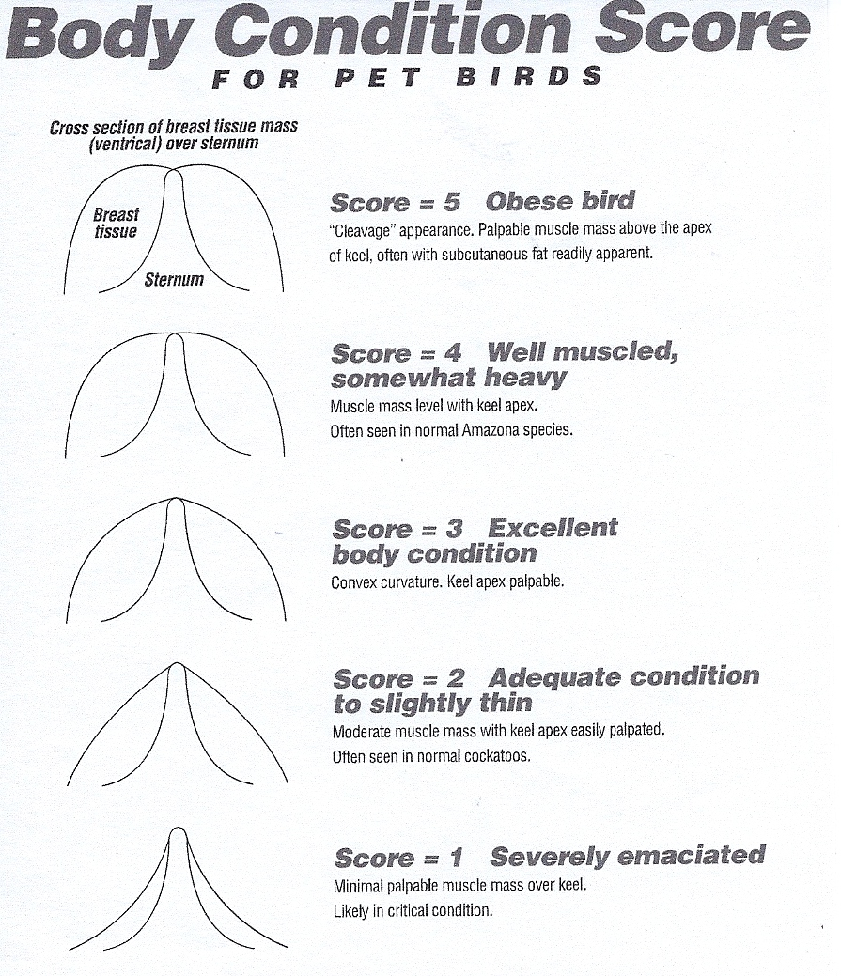
Forming a Proper Bond with Pet Parrots

In the wild, parrots can form three kinds of bonds: social bonds with flock members, a monogamous pair bond with a potential mate, and a mated pair that produce young. Birds raised with humans can form the same bonds.

Characteristics of social bonds:
- Birds feed and shelter together in flocks.
- Birds maintain minimal distance between each other.
- Birds occasionally preen each other for brief amounts of time.

Characteristics of monogamous pairs:
- Begin to spend more time together.
- Increased amounts of preening.
- Begin to seek out and defend a nest site.
- Begin courtship regurgitation.
- Initiate mating behavior.

Characteristics of a mating pair:
- Spend time exclusively with each other.
- Aggressively defend nest site.
- Aggressively drive off other flock members.

Ideally owners maintain only social bonds with pet parrots. Monogamous pair bonds and mated pair bonds often lead to undesirable behaviors. These include:

- Attempting to drive off or bite other human members of the household.
- Biting preferred owners when other people of pets come near
- Aggressively defending perceived “nesting sites” such as cages, boxes, etc.
- Increased regurgitation and mating behaviors.
- Screaming and agitation when separated from human “mate”
- Sexual frustration and feather plucking.

Ways to maintain a social pair bond and discourage other bonds:

- Encourage all family members to interact with the bird regularly and equally.
- Schedule times for the bird to meet and interact with willing strangers.
- Limit petting to brief, non-intense episodes, such as occasionally scratching the head.
- Maintain proper “social distance” for most interactions with the bird.
- Discourage all regurgitation or masturbating behavior.
- Remove any perceived nest site or nesting materials.
See our “Forming Social Bonds with Pet Birds” on our website www.exoticvetclinic.com under the “education” and “ video” links.

How Should I Play With My Bird?

In the wild, pet parrots are known to be extremely social, gregarious and to perform behaviors that to human observers appear to be play. As this is an important part of the natural behavior of birds in the wild, owners should replicate this as well as possible to help improve the captive bird’s mental welfare.

Unfortunately for some birds, a human’s conception of play can be misunderstood as courtship or reproductive behaviors, which can lead to a number of undesirable and unhealthy consequences, including reproductive disease, screaming, biting, preferring the company of only one human, delayed molt and in some cases feather destructive behavior.

Misunderstanding occurs when humans try to interact with pet parrots as they would a pet dog or cat, as the behaviors of these species among others of their kind are very different. The following desirable play activities tend to replicate social parrot behavior. The undesirable play activities can replicate the pair bond or mating behavior

Desirable Play Activities | Undesirable Play Activities
Step up and step down onto various perches in return for a treat for family members and confident strangers | Perching on human shoulders or head
Staying on perch or play gym when placed there | Leaving perch or play gym to explore the house on own
Social vocalization-talking, singing | Constant screaming
Social eating-sharing food items with other human flock members | Taking foods directly from human mouth (simulates courtship feeding)
Trick training, clicker training with food rewards | Intense cuddling with owner, for example under clothing
Limited social grooming-occasional scratch on head or under wings | Long periods of grooming by owners, especially near tail
Exploring toys and other safe novel objects | Masturbating with humans or toys
Foraging behaviors-toys or objects that replicate searching for food items | Nesting in boxes, or other materials
Meeting and socializing with unfamiliar but friendly humans | Interacting exclusively or even mostly with only one family member

Target Training for Birds

Target training is a fun and easy technique used to encourage desired behaviors such as entering a carrier or even trick training. In brief, the goal is to get the bird to willingly go to a target in anticipation of a reward.

Before you can begin you need 3 things:

- A target, which should be a readily available easily identified object that the bird normally would not see outside of training. Suggestions are: a chopstick, an unusually colored and/or shaped toy, a bell, etc.
- A clicker, available at most larger pet stores
- A reward that the bird really enjoys, never gets any other time, and can be consumed very quickly. Suggestions are 1/2 shelled sunflower seed, a bit of nut, a tiny bit of popcorn or dried fruit.

To begin, place the bird on a tabletop and place the target some distance away. Wait for the bird to approach the target and touch it with his beak. Immediately click, praise and offer the reward. Repeat until the bird learns touching the target means a reward.
In summary:

- Bird touches the target
- Bird hears a click
- Bird gets a verbal and treat reward at the same time he hears the click
- Bird associates target and click with reward
- Bird seeks out target to get a reward
- Owner uses target to shape behaviors.

Now you can place the target in various places to shape a behavior, for example, going into the carrier.

More ideas can be found by searching under “clicker training” here:
www.birdsjustwannahavefun.com/books
www.birdsupplies.com

Environmental Enrichment for Birds

Research on bird behavior in the wild shows that birds spend large amounts of time performing specific behaviors such as foraging for food, socializing and grooming. Research on birds in captivity suggest that replicating these behaviors can help improve a pet bird’s mental well being, and possibly reduce boredom, and related abnormal behaviors such as feather plucking.

Consider the lifestyle of a bird kept indoors in a cage with one or a few human companions, and a minimally varying diet easily available in a dish every moment of the day. Contrast this with the lifestyle of a bird in the wild, surrounded by a large social flock, and spending large amounts of time searching for food. This does not necessarily mean birds should not be kept as pets. One advantage of captivity is that birds are generally safe from adverse weather and predators. Many owners have found ways to keep birds in captivity yet still provide them with mental and physical stimulation that in some ways replicates life in the wild.

Foraging: In the wild adult birds must spend large amounts of time hunting and foraging for food. Placing food in a bowl for birds eliminates this natural behavior. Ideally all food should be presented as “forage”, and the food bowls eliminated (except for soft table foods).

Bury small pieces of food in a bowl filled with large pebbles or wooden beads to encourage the bird to dig and search for food.
Crumple food into paper so the bird has to unfold it to find the food.
Cover the bowl with paper secured with masking tape so the bird must rip open the paper to get to the food.
Buy commercial toys specifically designed for foraging.
More ideas are available here: www.exoticvetclinic.com under the “education” and “video” links “Training Your Bird to Forage”. Note there is a separate video for teaching cockatiels, budgerigars and finches to forage.

Socializing: Plan time specifically to replicate flock behaviors with multiple family members to discourage socialization with just a few, or worse, a single member of the household. Interacting constantly with a single-family member (human or bird) can encourage the bird to form a pair or sex bond. This often results in behaviors owners find objectionable. (See “Proper Bonding”) In households with only a single member, encourage other willing friends to help socialize the bird. Other ideas include:

Play “Warm Potato:” While sitting in a circle, pass the bird from person to person. Each participant should ask the bird to step up, and then reward the bird verbally or with a treat. Note: any bird that does not want to step up should not be forced!
Eat in a social group: Birds in the wild frequently eat together in large groups. Bring the bird near the table at mealtimes on a play stand, and “serve” the bird along with other family members.

Take the bird on social outings that include interacting with other willing people.
Remember that efforts to socialize a bird must continue throughout the bird’s lifetime.

Grooming

Nails: The nails of the wild parrot are normally very sharp to help them hang on to natural perches. However, sharp nails are uncomfortable for family members. They can also cause problems for captive birds as well, as nails tend to get caught on fabric. In the wild, parrots' nails seldom overgrow. As captive birds don't have the natural surfaces to wear them down, nails can overgrow in our captive pets. Some disease process, such as malnutrition, can cause abnormal nail growth as well.
Schedule your bird for a nail trim when you feel the nails are too sharp for comfort, or you can see they are beginning curl and catch on fabric.

Wings: Wing trims are designed to prevent flight in captive birds. This prevents injuries, and helps in case of accidental escape. However, many owners are foregoing the wing trim, and choosing to allow free flight in the home, in indoor or even outdoor aviaries. Free flight is something birds enjoy, and helps provide aerobic exercise for cardiovascular health. Allowing free flight requires some degree of training, and preventative measures to prevent injuries from hazards such as hot stovetops, candles and fireplaces, windows, ceiling fans and closing doors. Families should discuss the options with their veterinarians, and make a choice to clip or not to clip.



